1. Make sense of problems and persevere in solving them.
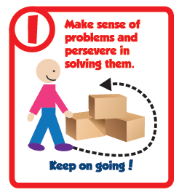
• Interpret and make meaning of the problem looking for
starting points. Analyze what is given to explain to
themselves the meaning of the problem.

• Plan a solution pathway instead of jumping
to a solution.

• Monitor the progress and change the approach
if necessary.

• See relationships between various representations.

• Relate current situations to concepts or skills previously learned and
connect mathematical ideas to one another.

• Students ask themselves, “Does this make sense?” and understand
various approaches to solutions.

Questions to Develop Mathematical Thinking

How would you describe the problem in your own words?
How would you describe what you are trying to find?
What do you notice about...?
What information is given in the problem?
Describe the relationship between the quantities.
Describe what you have already tried. What might you change?
Talk me through the steps you’ve used to this point.
What steps in the process are you most confident about?
What are some other strategies you might try?
What are some other problems that are similar to this one?
How might you use one of your previous problems to help you begin?
How else might you organize...represent...show...?

2. Reason abstractly and quantitatively.
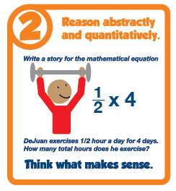
• Make sense of quantities and their relationships.

• Able to decontextualize (represent a situation
symbolically and manipulate the symbols) and
contextualize (make meaning of the symbols
in a problem) quantitative relationships.

• Understand the meaning of quantities
and are flexible in the use of operations
and their properties.

• Create a logical representation of the problem.

• Attend to the meaning of quantities, not just how to compute them.

Questions to Develop Mathematical Thinking

What do the numbers used in the problem represent?

What is the relationship of the quantities?

How is _______ related to ________?

What is the relationship between ______and ______?

What does_______mean to you? (e.g. symbol, quantity, diagram)

What properties might we use to find a solution?

How did you decide in this task that you needed to use...?
Could you have used another operation or property to solve this task?
Why or why not?

3. Construct viable arguments and critique the reasoning of others.
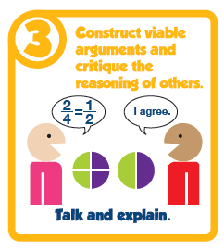
• Analyze problems and use stated mathematical assumptions, definitions, and established results in constructing arguments.

• Justify conclusions with mathematical ideas.

• Listen to the arguments of others and ask useful questions to determine if an argument makes sense.

• Ask clarifying questions or suggest ideas to improve/revise the argument.

• Compare two arguments and determine correct or flawed logic.

Questions to Develop Mathematical Thinking
What mathematical evidence supports your solution?

How can you be sure that...? / How could you prove that...? Will it still work if...?

What were you considering when...?

How did you decide to try that strategy?

How did you test whether your approach worked?

How did you decide what the problem was asking you to find? (What was unknown?)

Did you try a method that did not work? Why didn’t it work? Would it ever work? Why or why not?

What is the same and what is different about...?

How could you demonstrate a counter-example?
4. Model with mathematics.
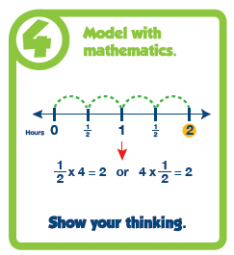
• Understand this is a way to reason quantitatively and abstractly (able to decontextualize and contextualize).

• Apply the math students know to solve problems in everyday life.

• Able to simplify a complex problem and identify important quantities to look at relationships.

• Represent mathematics to describe a situation either with an equation or a diagram and interpret the results of a mathematical situation.

• Reflect on whether the results make sense, possibly improving/revising the model.

• Ask themselves, “How can I represent this mathematically?”

Questions to Develop Mathematical Thinking

What number model could you construct to represent the problem?

What are some ways to represent the quantities?

What’s an equation or expression that matches the diagram? number line? chart? table?

Where did you see one of the quantities in the task in your equation or expression?

Would it help to create a diagram, graph, table, …?

What are some ways to visually represent…?

What formula might apply in this situation?
5. Use appropriate tools strategically.
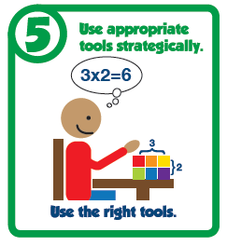
• Use available tools recognizing the strengths and limitations of each.

• Use estimation and other mathematical knowledge to detect possible errors.

• Identify relevant external mathematical resources to pose and solve problems.

• Use technological tools to deepen their understanding of mathematics.

• Use mathematical models for visualizing and analyzing information

Questions to Develop Mathematical Thinking
What mathematical tools could we use to visualize and represent the situation?

What information do you have?

What do you know that is not stated in the problem?

What approach are you considering trying first?

What estimate did you make for the solution?

In this situation would it be helpful to use.a graph..., number line..., ruler...,
diagram..., calculator..., manipulative?

Why was it helpful to use ____?

What can using a ______ show us that _____may not?

In what situations might it be more informative or helpful to use...?

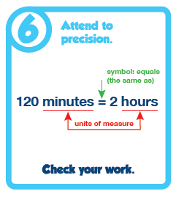
6. Attend to precision.
• Communicate precisely with others and try to use clear mathematical language when discussing their reasoning.

• Understand meanings of symbols used in mathematics and can label quantities appropriately.

• Express numerical answers with a degree of precision appropriate for the problem context.

• Calculate efficiently and accurately.

Questions to Develop Mathematical Thinking
What mathematical terms apply in this situation?

How did you know your solution was reasonable?

Explain how you might show that your solution answers the problem.

Is there a more efficient strategy?

How are you showing the meaning of the quantities?

What symbols or mathematical notations are important in this problem?

What mathematical language..., definitions..., properties can you use to explain...?

How could you test your solution to see if it answers the problem?
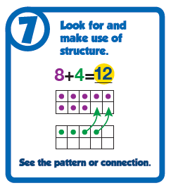
7. Look for and make use of structure.

• Apply general mathematical rules to specific situations.

• Look for the overall structure and patterns in mathematics.

• See complicated things as single objects or as being composed of several objects.

Questions to Develop Mathematical Thinking
What observations do you make about...?

What do you notice when...?

What parts of the problem might you eliminate? simplify?

What patterns do you find in...?

How do you know if something is a pattern?

What ideas have we learned before that were useful in solving this problem?

What are some other problems that are similar to this one?

How does this relate to...?

In what ways does this problem connect to other mathematical concepts?

8. Look for and express regularity in repeated reasoning.
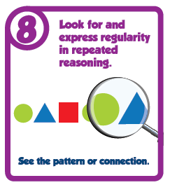
• See repeated calculations and look for generalizations and shortcuts.

• See the overall process of the problem and still attend to the details.

• Understand the broader application of patterns and see the structure in similar situations.

• Continually evaluate the reasonableness of their intermediate results.

Questions to Develop Mathematical Thinking
Will the same strategy work in other situations?

Is this always true, sometimes true or never true?

How would you prove that...?

What do you notice about...?

What is happening in this situation?

What would happen if...?

Is there a mathematical rule for...?

What predictions or generalizations can this pattern support?

What mathematical consistencies do you notice?

