|  |  |  |
| --- | --- | --- |
| Questions | Points | Proficiency |
| Level 1 | ____/2 | 0-10 Unsat  11-12 PPL  13-14 PPH  15-16 Prof |
| Level 2 | ____/6 |
| Level 3 | ____/6 |
| Level 4 | ____/4 |
| Total | | * 1. Adv |

1. ****Which table best describes the graph? (1 point)

|  |  |  |  |  |  |  |  |  |  |  |
| --- | --- | --- | --- | --- | --- | --- | --- | --- | --- | --- |
| **x** | **Y** |  | **x** | **y** |  | **x** | **y** |  | **X** | **y** |
| **5** | **-1** |  | **1** | **5** |  | **-1** | **5** |  | **-1** | **5** |
| **0** | **2** |  | **2** | **0** |  | **0** | **2** |  | **2** | **0** |
| **-1** | **1** |  | **3** | **-1** |  | **1** | **-1** |  | **1** | **-1** |
| **-4** | **2** |  | **4** | **-4** |  | **2** | **-4** |  | **2** | **-4** |

**A B C D**

1. Pauly D is going to the beach with the rest of the Jersey Shore Cast. The taxi ride there costs him 6 dollars plus 1.25 dollars per mile. Write an equation to represent how much it will cost him to ride in the taxi to get to the beach. (1 point)
$y=1.25x+6$

$y=6x+1.25$

$y=x+6$

$y=x-1.25$

2. Jenna kept track of the total number of outfits that she wore to school over the past 5 years. She recorded her data in the table below. (2 points)

|  |  |  |  |  |  |
| --- | --- | --- | --- | --- | --- |
| Years (n) | 1 | 2 | 3 | 4 | 5 |
| Total Outfits (T) | 5 | 9 | 13 | 17 | 21 |

Which of the equations below could Jenna use to determine how many outfits she wears after any number of years?

$T=4n+1$

$T=4n+5$

$T=n+4$

$n=4T+1$

1. Marty has $80 to spend at a sporting goods store. He will spend $56 on a shirt, and then buy some darts. Each box of darts cost $6. He spends all of his money. Which equation shows how to find the number of boxes of darts, x, he can buy? (2 points)
$$80=56+6x$$

$$80=56-6x$$

$$80=(56)(6x)$$

$$80=\frac{56}{6x}$$

2. Jeremy mows lawns in the summer to make money. He goes to Walmart and buys a mower for 50 dollars with his own money. Jeremy charges people 18 dollars per lawn that he mows. Let (p) stand for the profit Jeremy makes over the summer, and (n) stand for the number of lawns he mows. Which equation represents the total amount of profit Jeremy earns mowing lawns? (3 points)
$p=18n+50$

$p=50n+18$

$n=18p-50$

$p=18n-50$

3. Kenya is going to Eliches. The park cost is 5 dollars to enter, and another 1.50 dollars per ride. If (c) represents the total cost and (n) represents the number of rides Kenya went on, which equation below can Kenya use to help her figure out how much money the trip will cost her? (3 points)
$n=1.5c+5$

$c=5n+1.5$

$c=1.5n+5$

$c=-1.5n+5$

4. Maria spends $4 dollars on candy at the 7-Eleven before school. If she sells each piece of candy for $0.50, write an equation representing Maria’s total candy profit (t) in relation to the number of candies she sells (c). (3 points)

1. Write the equation:_________________________________
2. Complete the table:

|  |  |  |  |  |  |
| --- | --- | --- | --- | --- | --- |
| Number of Candies Sold (c) | 0 | 1 | 2 | 3 | 4 |
| Total Profit (p) |  |  |  |  |  |

1. Graph the equation on the coordinate grid below: *make sure you use title and labels*

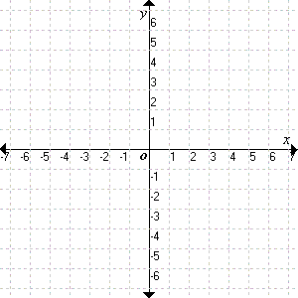

1. If Maria’s total profit is only $1.50 then how many pieces of candy did she have to sell? *Show all work to get credit!*

Number of candy:________________________

1. Square tiles were used to make the pattern below: (4 points)

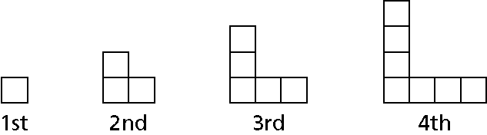

**a.** Complete the table that shows the relationship between the pattern number (p) and the total number of tiles (t)

|  |  |  |  |  |  |  |
| --- | --- | --- | --- | --- | --- | --- |
| Pattern number (p) | 1 | 2 | 3 | 4 | 5 | 6 |
| Number of tiles (t) |  | 3 |  |  |  |  |

**b.** Write an equation for the number of tiles, *t*, in relation to the pattern number *p*.

**c.** Describe the pattern represented by the equation and table above. Use 3 of the terms below in your explanation:  *independent variable, dependent variable, rate of change, initial value, increase, decrease*

________________________________________________________________________________________________________________________________________________________________________________________________________________________________________________________________________________________________________________________

**d.** On the coordinate grid below, make a graph of the data. Be sure to include scales and titles for each axis.