Infinite Solutions, No Solution, One Solution

One Solution:

2x + 4 = 4(x + 2)

2x +4 = 4x + 8

4 = 2x + 8

-4 = 2x

x = -2

Each expression is a linear expression. When solving for x, we found the x coordinate where the two linear expressions intersect. To find the y coordinate, you can substitute -2 into either expression and get 0. This means the lines cross at (-2, 0).

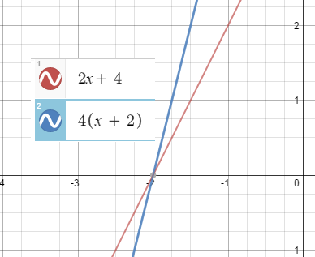
When linear expressions cross at 1 point, then we say there is “One Solution”

No Solutions:

5x + 10 = 5(x +3)

5x + 10 = 5x + 15 (Notice how each expression is now linear and in mx + b form)

10 = 15

Both linear expressions have the same slope (5) but different y –intercepts (10 and 15). This means the lines are parallel and will never intersect. Therefore, there is no solution.

In other words, there is no value for x that we can substitute into the equation to make a true statement.

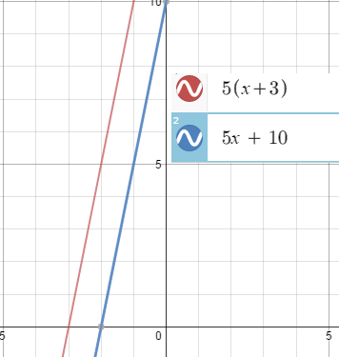

Infinite Solutions:

4x + 2 = 2(2x + 1)

4x + 2 = 4x + 2 (Notice how both linear expressions have the same slope (4) and y-intercept (2)

2 = 2 If we continue to simplify, then we will end up with a true statement,
Or such as 2 = 2, or x = x.
4x = 4x
Or
x = x

When we end up with a true statement, this means the two linear expressions are equivalent. If you were to graph each expression, you would be graphing the same line.

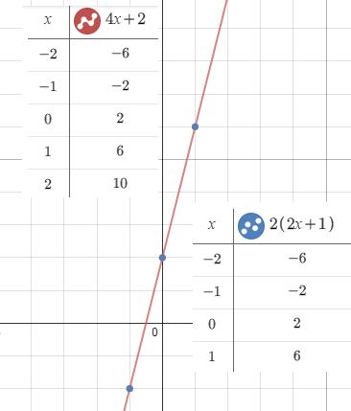

Homework Assignment:

- Write an equation with x on both sides that represents 1 solution
.
  - Show the algebraic steps that solve for the x value
  - Substitute x into the equation and solve for y
  - Create a graph that shows the two linear expressions intersecting
  - Create a table that also shows the point of intersection
  - Write a short paragraph that describes the meaning of “1 solution”

- Write an equation with x on both sides that represents no solutions

- Show the algebraic steps that solve for the x value
- Graph each expression
- Create a table for each expression
- Write a short paragraph that describes the meaning of no solution and how you can identify it based on a table, graph and equation.

- Write an equation with x on both sides that represents infinite solutions.
- Show the algebraic steps that show there are infinite solutions
- Graph each expression
- Create a table for each expression
- Write a short paragraph that describes the meaning of infinite solutions and how you can identify it based on a table, graph, and equation

Extra Credit:
Write a word problem for each example and describe how no solution, infinite solutions, or 1 solution apply to the real world meaning of your problem.

