Name: 8th Grade Algebra
Week of March 20th
Systems of Linear Equations Review
Skill 1: I can convert an equation from Standard Form (Ax + By = C) to slope intercept form ( y = mx + b)
Passenger Co- Pilot Pilot
-6x + y = 12 4x + 8y = 24 -2x + 4y = 24

Passenger Co- Pilot Pilot
4x + y = 20 -3x + 6y = 36 -x + 4y = - 20

Skill 3: I can solve for an equation when there is a variable on each side.
Passenger Co- Pilot Pilot
3x + 4 = 2x + 10 2x – 3 = x + 3 -4 + 2x = -x + 11

Passenger Co- Pilot Pilot
5x + 10 = x + 30 3x – 19 = 5 – x 2x – 16 = 14 – 3x

Passenger Co- Pilot Pilot
-4 + 3x = 11 – 2x x - 9 = 3 – 3x 2x – 17 = -3x + 18

Passenger Co- Pilot Pilot
10 + 3x = 50 – 2x 2x + 9 = 3 – 4x 1.5x + 18 = 1x + 24

Skill 2: I can graph two linear equations and find the solution to a system of equations.
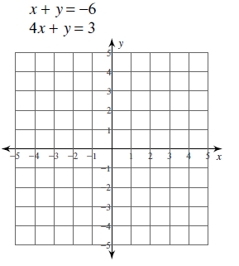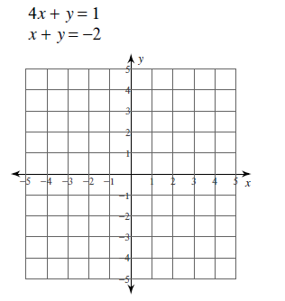

John tried to solve the following equation. Identify any mistakes made by John.
3x + 18 = - 2x – 17

Skill 4: I can identify when a system of equations has 1 solution, no solutions (parallel), or infinite solutions (same line)
A solution to a system of linear equations is where two lines _____________________________.
A system that has no solutions means the lines ________________________________________.
A system that has infinite solutions means the lines _____________________________________.
Distribute and/or combine like terms to determine if each equation has 1 solutions, no solutions, or infinite solutions.
Passenger Co- Pilot Pilot
2x + 5 = 2x + 10 2x + 2x + 4 = 2(2x + 1) 2.5(3x + 4) = 7.5x + 10

Passenger Co- Pilot Pilot
3x + 1 = 10x + 1 3(2x – 10) = 5x + 10 – x 0.5(8x - 4) = 5x + 2x + 2

Passenger Co- Pilot Pilot
7x + 4 = 4 + 7x 4(2x + 1) = 5x + 7 + 3x – 3 -2x – (5x + 1) = -(7x + 2) - 3

Skill 5: I can apply systems of linear equations to solve word problems.
Overall Mastery:
- I can covert two equations from Standard Form (Ax + By = C) to slope intercept form (y = mx + b).
- I can set the equations equal to each other and solve for x.
- I can substitute x and solve for y to find the point where two lines intersect.

Example 1: Example 2:
-8x + 2y = 16 -7x + y = 12
-2x + y = 16 8x + 2y = - 64

Challenge Problem:
Instructions: 1. Define your variables for each equation 2. Write two equations for the given information in the problem. 3. If necessary, convert equations from Standard Form (Ax + By = C) to slope-intercept form. 4. Set the mx + b expressions equal to each other and solve for x. (Attach your work on a separate sheet if needed)

- Your teacher is giving you a test worth 100 points containing 40 questions. There are two‐point and four‐point questions on the test. How many of each type of question are on the test?

